 STAFF REPORT

February 1, 2006

To: Toronto and East York Community Council

From: Director, Community Planning, Toronto and East York District

Subject: Directions Report
629, 633 and 675 Eastern Avenue
04-168616 STE 30 OZ

Ward 30 - Toronto-Danforth

Purpose:

To seek Council’s direction on an appeal to the Ontario Municipal Board (OMB) by owner/applicant's of their application for an Official Plan and Zoning By-law Amendment.

Financial Implications and Impact Statement:

There are no financial implications resulting from the adoption of this report.
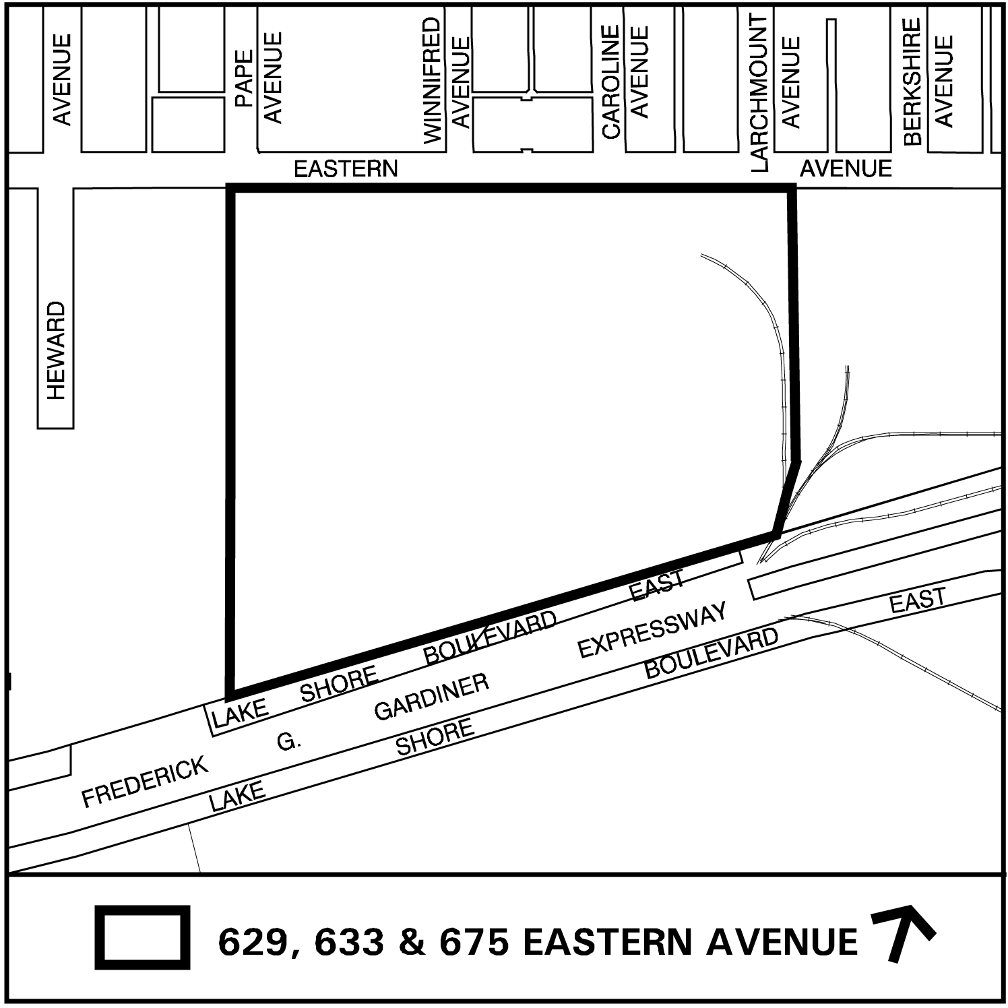

Recommendations:

It is recommended that City Council:

(1) refuse the application for 629, 633 and 675 Eastern Avenue in its current form and authorize the City Solicitor and appropriate City staff to attend the Ontario Municipal Board hearing to oppose the subject application;

(2) authorize staff to enter into discussions with the applicants to work towards a settlement position and direct staff to bring forward any proposed settlement to City Council; and

(3) Authorize staff to establish in consultation with the Ward Councillor, a working committee to provide input on the South of Eastern Study.

Background:

An application for a Rezoning and Official Plan Amendment was received by the City on August 24, 2004. The applicant submitted a Public Realm and Master Plan document and Urban Design Guidelines in support of the application.

Original Applicant Proposal

The applicants propose Official Plan and zoning amendments to permit a range of office, service retail, hotel and residential uses with specific height limits. A Holding (H) provision is proposed in the zoning by-law to ensure that:

- Council is satisfied that roads and other services are provided within the site, and that adequate parking and loading facilities are available;

- A Site Plan application has been approved;

- Council is satisfied that the site meets the Provincial standards for decommissioning of contaminated sites; and

- Where residential uses are proposed, that the site is appropriate for those uses.

Staff Reports

At its meeting on November 16, 2004, the Toronto and East York Community Council approved the staff recommendations contained in a Preliminary Report dated October 21, 2004. In doing so, Toronto and East York Community Council requested planning staff to undertake a review of the planning strategy for the area bounded by Lake Shore Boulevard East, Don Valley, Leslie Street and Eastern Avenue in consultation with the Ward Councillor and the community as appropriate. This study is underway.

At its meeting on July 19, 20, 21 and 26, 2005 City Council adopted the “Status Report – South of Eastern Study- 629, 633 and 675 Eastern Avenue and the recommendations as follows:

(1) adopt the staff recommendations in the Recommendations Section of the report (June 21, 2005) from the Director, Community Planning, South District subject to amending Recommendation (3) to read:

“(3) direct appropriate staff of the Economic Development and Culture Division and the Director, Waterfront Secretariat to report to Economic Development and Parks Committee for information, and to the Toronto and East York Community Council on the availability of suitable space in Toronto for the film sector and its needs with respect to future expansion and growth, and to consult with appropriate municipal departments, agencies, boards and commissions and the Toronto Waterfront Revitalization Corporation, when preparing this report”;

(2) request the Director, Transportation Services, Toronto and East York District to undertake a traffic study in the area covered by the Community Improvement Plan which would address the outstanding Community Improvement Plan issues as well as the above requests and concerns as identified by the surrounding community. The results of the traffic study would:

(a) move commuter traffic off of local streets;

(b) address traffic calming on Eastern Avenue from Carlaw to Coxwell and local streets;

(c) meet school zone concerns;

(d) solve pedestrian concerns at the big box centres at Lakeshore and Leslie/ Lakeshore and Eastern; and

(e) finish implementation of Community Improvement Traffic Projects;

(3) request the Chief Planner and Executive Director, City Planning, in consultation with other appropriate City divisions and agencies, to report to the Toronto and East York Community Council, and to the Economic Development and Parks Committee for information, on the steps to be taken to maintain the current “Studio District” designation in the vicinity of Eastern Avenue, including maintaining street signs;

(4) as part of the economic study being undertaken in the South of Eastern Study area, request the Chief Planner and Executive Director, City Planning, in consultation with Economic Development and Culture Division and the Director, Corporate Finance, to report to Toronto and East York Community Council and to the Economic Development and Parks Committee for information, on:

(a) the nature of employment, and the number and type of jobs, in the Kings area of the City of Toronto after redevelopment, compared to conditions prior to redevelopment;

(b) the applicability of the Kings experience to the South of Eastern study area and the proposed rezoning of 629, 633 and 675 Eastern Avenue;

(5) request the Chief Planner and Executive Director, City Planning, in consultation with Economic Development and Culture Division and the Director, Corporate Finance, to report to the Toronto and East York Community Council and to the Economic Development and Parks Committee on incentives for employment uses to promote new investment for employment purposes and to maintain and grow the city’s job base; and

(6) request the Director, Community Planning, South District to have regard for the leasing of the new studio space in the Port Lands while preparing the Final Report respecting the application for zoning amendments for 629, 633 and 675 Eastern Avenue and have in mind timing and other issues discussed at the July 5, 2005 Toronto and East York Community Council meeting.

It had been staff’s intention to report on the South of Eastern Study, and related Council recommendations, with this application. The appeal by the applicant has prompted a separate report requesting Council direction on the Ontario Municipal Board appeal. Staff will report on the study and related recommendations in the 2nd quarter of this year.

Comments:

Site Description

The 7.5 ha (18.6 ac) site is on the south side of Eastern Avenue, at Pape Avenue. It includes lands formerly occupied by the Toronto Iron Works and the A. R. Clarke Tannery. The site currently houses one of the country’s largest film and television production facility with approximately 22,296 m2 (240,000 sq. ft.) of space. The former A. R. Clarke site is vacant and is occasionally used for parking.

Surrounding Uses:

West: a towing yard and automobile dealership
South: Lake Shore Boulevard and film studio and related uses
East: Canada Metals site
North: residential area

The Policy Framework

The Former City of Toronto Official Plan

The application site falls within an area designated Restricted Industrial Area. It is Council’s policy to discourage the loss of employment land by encouraging the retention and renewal of employment in the City’s industrial areas.

Policy Section 9.18 of Part I of the Official Plan states that Council will not consider a redesignation of any industrially designated land for any non-industrial use without first having considered a study of the area. Amongst other matters, the study shall have regard for:

(a) the number and types of industrial firms and employees in the areas that would be adversely affected;

(b) the impact on any surrounding industrial lands that would not be redesignated; and

(c) the environmental condition of the lands and the need for soil decommissioning.
Restricted Industrial Areas shall be regarded as areas containing a limited range of industrial uses that are environmentally compatible with adjacent open space, parks or recreational uses and residential or commercial areas.

In Restricted Industrial Areas, Council may pass by-laws to permit:

(a) industrial buildings or uses having maximum densities based on an appropriate study which has considered area specific objectives for uses, urban design built form and density up to 5 times the area of the lot,

(b) industrial buildings or uses which have a minimal environmental impact on neighbouring buildings or uses, and

(c) commercial and/or industrial buildings or uses incidental to industrial uses or areas.

It is the policy of Council to encourage the retention and renewal of industry in the City’s industrial areas. Council will not consider redesignation of industrially designated land so as to permit any non-industrial use in areas designated as Restricted Industrial Area without first having considered a study of the area.

The New City of Toronto Official Plan

The new Official Plan for the amalgamated City of Toronto is now before the Ontario Municipal Board. Once the Plan comes into full force and effect, it will designate the Toronto Film Studio Site as an Employment Area. Employment Areas are places of business and economic activity consisting of offices, manufacturing, warehousing, distribution, research and development facilities, utilities, media facilities, parks, hotels, retail outlets ancillary to the preceding uses, and restaurants and small scale stores and services that serve area businesses and workers.

The site is included within an Employment District shown on the Urban Structure map (Map 2). Employment Districts play an important role in the Plan’s growth management strategy. They are large districts comprised exclusively of lands where the Employment Areas land use designation applies. These lands can accommodate substantial growth in jobs and meet the needs of some of the key economic clusters that are the focus of the City’s Economic Development Strategy.

The Plan states that Employment Districts will be protected from the encroachment of non-economic functions. The Plan therefore contains polices to protect and promote Employment Districts exclusively for economic activity in order to ensure a stable environment for investment, maintain and grow the City’s tax base, offer suitable locations for a variety of employment uses and nurture key economic clusters that benefit from these strategic locations.

The Toronto Film Studio site falls within what is considered an “edge condition” of an Employment Area. The new Official Plan would provide for the consideration of large format warehouse use (big box retail) on major arterial roadways shown on Map 3. Both Eastern Avenue and Lakeshore Boulevard are major arterial roads shown on this map. However, neither Eastern Avenue nor Lake Shore Boulevard are envisioned as Avenues under the new Official Plan.

Provincial Policy Statement

The March, 2005 Provincial Policy Statement (PPS) provides policy direction on matters of provincial interest related to land use planning and development. The March 2005 Policy Statement came in after this site specific application was submitted. The Province has a stated interest in protecting the long-term health and safety of the population, and the financial and economic well-being of the Province and municipalities. Economic prosperity, environmental health and social well-being depend on managing change and promoting transit accessible, cost-efficient, cost-effective development and land use. This includes reducing the potential for public cost or risk to Ontario’s residents by directing development away from areas where there is a risk to public health or safety.

The PPS supports a comprehensive, integrated and long-term approach to planning and recognizes linkages among policy areas. A key difference between this version and the previous 1997 version is that planning authorities must now make decisions on planning matters that are “consistent with” the policies of the PPS. The 1997 version stated that planning authorities should make decisions that “have regard to’ the policies of the PPS. The new PPS policies support and complement many of the City’s Official Plan’s objectives.

Zoning

The site is zoned I2 D5 – Restricted Industrial Area. This zone permits a range of service uses, workshops, auto related uses, warehousing and storage and transportation related activities. Residential uses or artist live/work studios are not permitted. Retail uses are only permitted if they existed on or before July 20, 1993 and there are limitations on the amount permitted and the possibility for expansion. The maximum permitted density is five times the area of the lot. Within 36.6 metres of Eastern Avenue on the south side, height is also limited to 18 metres. South of this point there is no height limit for industrial uses.

Actions by the Applicant

For the review of the development application, the applicant was required to submit an Ecomonic Review. This review as received by the City on December 22, 2005. Staff are reviewing the study.

After the Status Report was considered by City Council in July, the applicant requested the City to put their application on hold.

On December 30, 2005, the City received a letter from the applicant’s solicitor stating they were compiling an appeal to the Ontario Municipal Board. The reason for the appeal is Council’s failure to make a decision on the application.

On January 19, 2006, at the request of the applicant, Planning staff met with a representative of Toronto Film Studios (the applicant) and a representative from The Rose Corporation (the owner). The owner and applicant stated that they would like to work with the City towards a settlement prior to setting an Ontario Municipal Board hearing date. The applicant and owner advised that they would like to work together on a built form solution for the site. This would include the following:

- the elimination of the proposed residential uses;
- a significant retail component; and
- various accessory uses and a broad list of uses.

The applicant has provided the following principles as a basis for working towards a settlement:

1. the applicant agrees to work with the City on the basis of no residential uses;

2. the applicant will work with City staff to develop a full range of uses appropriate for the site;

3. the applicant will, with City staff, develop a set of urban principles on built-form parameters for the project;

4. City staff will report to the June TEYCC on the conclusions of the discussions; and

5. the applicant will not seek an early Board Hearing date.

Given that the existing film studio uses will continue on the site for some time and the fact that there is a vacant parcel of land to the east, the applicant would like to have a comprehensive plan for the entire site which includes a strategy to move ahead with development permission for the (former A. R. Clarke) vacant parcel.

Staff’s Response to the Applicant’s Request

With the applicant’s appeal to the Ontario Municipal Board, consideration of the South of Eastern Study and consideration of this site specific application has become a two step process.

Staff will be reporting in the 2nd quarter of this year on the results of the South of Eastern Study. This will include a request for a Public Meeting under the Planning Act to consider policies, and possibility zoning changes, to expand the range of permitted employment uses. Any consideration of retail permission must be reviewed in the context of the overall study area.

There are many issues specific to this site, including, but not limited to:

- appropriate mix of uses;
- access to Lakeshore Boulevard East;
- creation of new public streets within the site;
- north/south links through the site and to the lake;
- general traffic impacts;
- the future of Eastern Avenue and improvements to the streetscape;
- transit and auto, pedestrian and cycling facilities;
- future community benefits and green space; and
- environmental issues

The history of the environmental conditions of many of the sites south of Eastern Avenue must be considered as each development parcel comes forward. The potential for land use conflict must be addressed given the surrounding lands are not before us.

The proposed development must, among other matters, be compatible with the surrounding area with respect to use built form, and character. Council must be satisfied that the proposed development will “grow” the job base and not adversely affect the economic activity of the retail strips. Through a concentrated dialogue with the applicant on these and other issues, solutions may emerge.

As part of a possible settlement, staff will not consider the request for residential uses on these employment lands. This view is consistent with the policies concerning Employment Lands.

Conclusions:

The Official Plan and Zoning By-law Amendment application submitted for 629, 633 and 675 Eastern Avenue has been appealed to the Ontario Municipal Board. Planning staff have significant concerns with this application and do not support the introduction of residential on these lands. The applicants have agreed to work with staff on the basis of no residential component as part of their application. Staff are seeking direction to continue discussions with the applicant to work towards a settlement for the pending Ontario Municipal Board hearing.

Contact

Denise Graham, Senior Planner, East Section
Ph: (416) 392-0871
Fax: (416) 392-1330
E-mail: dgraham1@toronto.ca

Gary Wright
Director, Community Planning, Toronto and East York District

(p:2006\upd\pln\063844.doc) – smc

List of Attachments:

Attachment 1: Application Data Sheet
Attachment 2: Official Plan
Attachment 3: Zoning
Attachment 1: Application Data Sheet

Application Type |  | Official Plan Amendment & Rezoning |  |  |  |  |  | Application Number: |  |  |  |  | 04 168616 STE 30 OZ
Details |  | OPA & Rezoning, Standard |  |  |  |  |  | Application Date: |  |  |  |  | August 24, 2004
Municipal Address: |  | 629 EASTERN AVE, TORONTO ON
Location Description: |  | PL 81 PT LT5 & WATER LT CON FB PT TWP LTS 11 & 12 **Grid S3013
Project Description: |  | Proposed redevelopment of Toronto Film Studios site to permit future development of employment and residential uses.
Applicant: |  | Agent: |  |  |  | Architect: |  |  |  |  | Owner:
Cassels, Brock & Blackwell, Stanley Makuch |  |  |  |  |  |  |  |  |  |  | Bluefield Development; 1450755 Ontario Inc; 1450756 Ontario Inc.,
PLANNING CONTROLS
Official Plan Designation: |  | Restricted Industrial Area |  |  |  |  | Site Specific Provision:
Zoning: |  | I2 D5 |  |  |  |  | Historical Status:
Height Limit (m): |  | 18 |  |  |  |  | Site Plan Control Area: |  |  |  |  |  |  | Y
PROJECT INFORMATION
Site Area (sq. m): |  |  | 74862 |  |  |  | Height: |  | Storeys: |  |  | 0
Frontage (m): |  |  | 0 |  |  |  |  |  | Metres: |  |  | 0
Depth (m): |  |  | 0
Total Ground Floor Area (sq. m): |  |  | 0 |  |  |  |  |  |  |  |  |  |  |  | Total
Total Residential GFA (sq. m): |  |  | 0 |  |  |  |  |  | Parking Spaces: |  |  |  |  |  | 0
Total Non-Residential GFA (sq.m): |  |  | 0 |  |  |  |  |  | Loading Docks |  |  |  |  |  | 0
Total GFA (sq. m): |  |  | 0
Lot Coverage Ratio (%): |  |  | 0
Floor Space Index: |  |  | 0
DWELLING UNITS |  |  |  |  | FLOOR AREA BREAKDOWN (upon project completion)
Tenure Type: |  |  |  |  |  |  |  |  |  | Above Grade |  |  |  |  |  | Below Grade
Rooms: |  | 0 |  | Residential GFA (sq. m): |  |  |  |  |  | 0 |  |  |  |  |  | 0
Bachelor: |  | 0 |  | Retail GFA (sq. m): |  |  |  |  |  | 0 |  |  |  |  |  | 0
1 Bedroom: |  | 0 |  | Office GFA (sq. m): |  |  |  |  |  | 0 |  |  |  |  |  | 0
2 Bedroom: |  | 0 |  | Industrial GFA (sq. m): |  |  |  |  |  | 0 |  |  |  |  |  | 0
3 + Bedroom: |  | 0 |  | Institutional/Other GFA (sq.m): |  |  |  |  |  | 0 |  |  |  |  |  | 0
Total Units: |  | 0
Contact: | Planner Name: |  |  | Denise Graham, Senior Planner - East Section
 | Telephone: |  |  | (416) 392-0871
Attachment 2: Official Plan

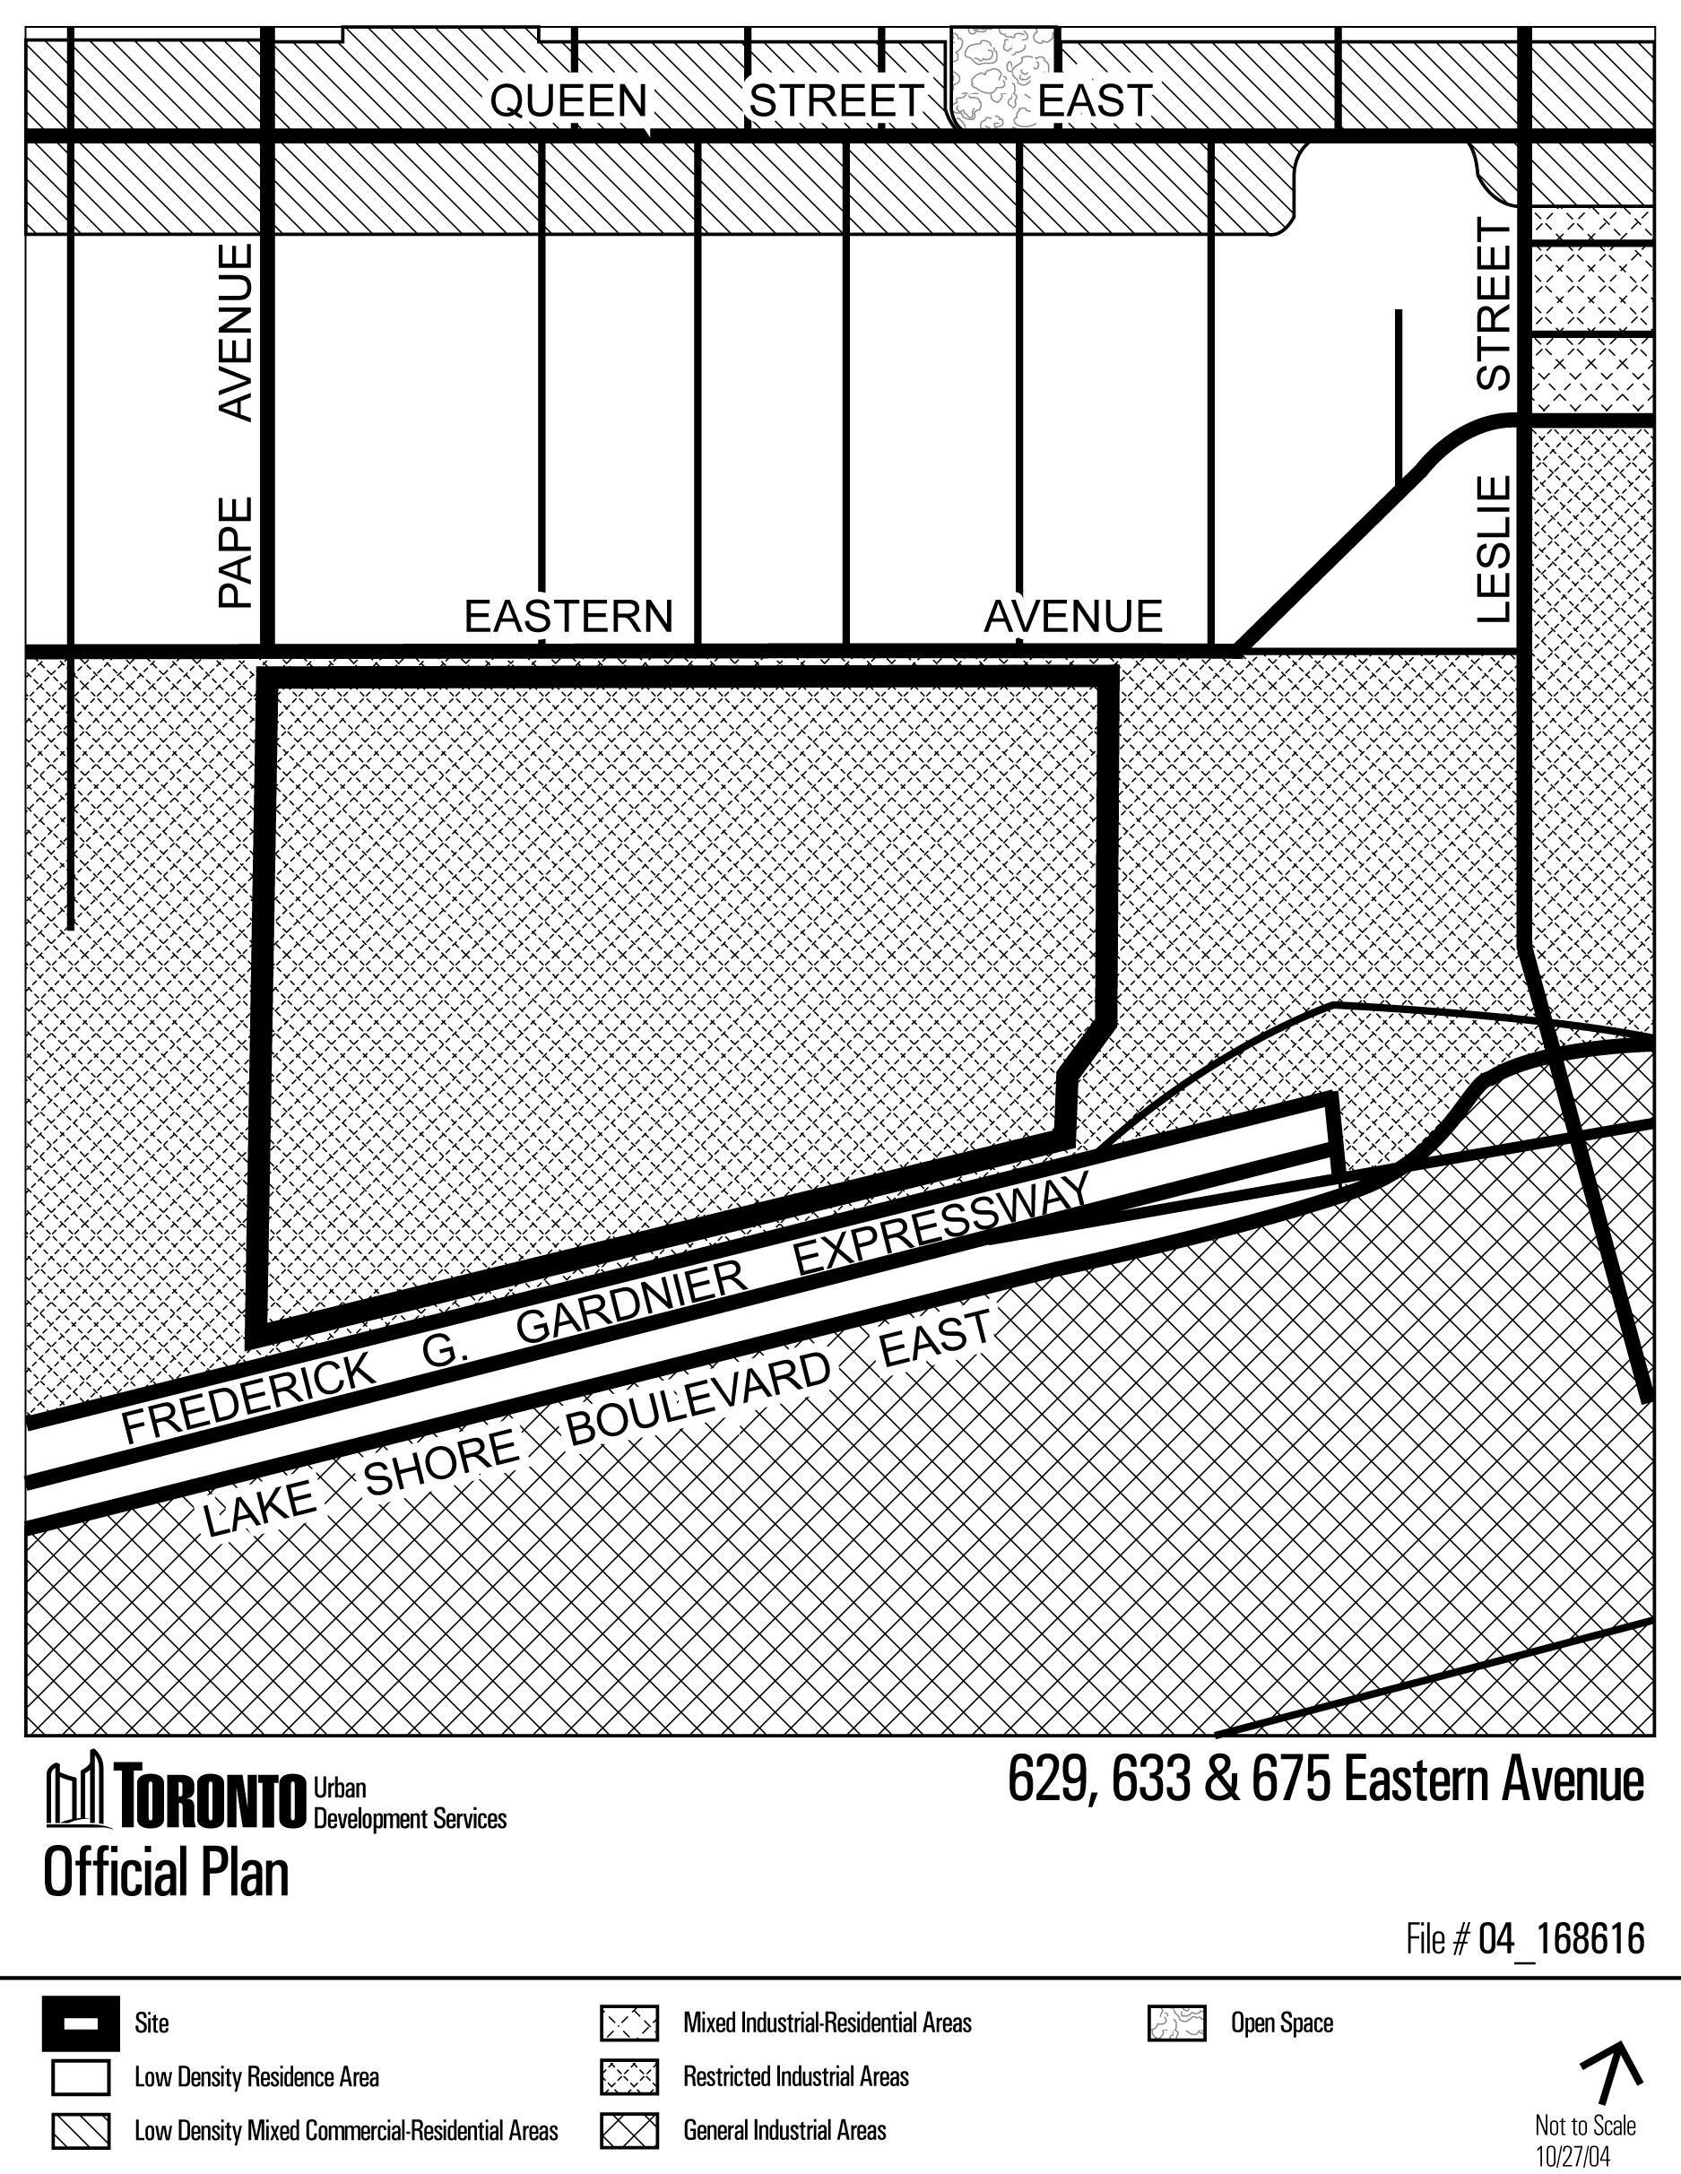

Attachment 3: Zoning

